**SNIA Functional Specs**

|  |  |  |
| --- | --- | --- |
| **Author** | **Date** | **Version** |
| **Sravanthi** | **11/10/2017** | **0.1** |
|  |  |  |

Contents

1 Overview 3

2 Introduction 3

3 Environment 3

3.1 Environment Set up 3

4 Functional blocks 4

4.1 Login 4

4.2 Process Engine 4

4.2.1 Add Swordfish Services 4

4.2.3 Delete Swordfish Service 4

4.2.4 Add Collection 4

4.2.5 Delete Collection 5

4.2.6 Edit Properties 5

4.2.7 Logout 5

4.2.8 Implementation 5

5 SNIA Screens 5

5.1 Landing Page 5

5.2 Add a Swordfish Service 6

5.3 Delete a Swordfish Service 7

5.4 Collections Page 8

5.5 Edit Properties 10

5.6 Add a service to collection 12

5.7 Remove a service form collection 12

5.8 Logout 13

5.9 batch commads 13

# Overview

SNIA basic Web Client organizes collection’s data in a blade interface by elaborating it into 3 sections

**Properties**: give a clear demonstration of the basic

**Links:** display the links present in the collection.

**OData:** keeps a track of information such as copyright, context, type etc.

# Introduction

SNIA basic Web Client gives a clear demonstration of collections and it’s sub collections data in a blade interface.

A detailed view of real time system’s data is organized by

# Environment

Node.js and npm are essential to run the SNIA basic Web Client. Node powers client development and build tools. The npm package manager, itself a node application, installs JavaScript libraries.

|  |  |
| --- | --- |
| **Operating System** | Windows |
| **Node.js** | v.8.1.1 |
| **Npm** | v5.0.3 |
| **Angular/cli** | 1.4.5 |
| **Express** | 4.15.5 |
| **IDE** | Webstrom |

## Environment Set up

1. Download the node.js from <https://nodejs.org/en/download/>
2. Required npm, express and angular/cli installation commands are provided in a batch (commands.bat) file.
3. Run the batch file for successful installation of npm ,express and angular/cli

Image: commands.bat

1. Install Webstrom
2. Open the project in Webstrom
3. Go to terminal tab and run **cd views** && **npm install**
4. After successful installation of dependencies, **npm build** && **cd .. .**
5. run **npm install**. It will add all the local dependencies to the node modules folder as specified in the package.json.
6. Or open the project in file explorer, open command prompt and run the following command’s

**cd views** && **npm install**

**npm build**

**cd ..**

**npm install**

**npm start**

1. After successful build ,open browser and visit **http://localhost:3000** to access the application

# Functional blocks

SNIA basic web client is composed of the following components in the form of input’s, associated functionalities.

## Login

Allows the User to avail the features of SNIA basic web client by authenticating

User needs to provide Username and Password.

Username: [snia](mailto:snia@gmail.com)

Password: snia@123

Image:Landing Page

## Process Engine

### 4.2.1 Add Swordfish Services

A new blade will visible to user with a form containing IP address, Domain Name, User Name and Password.

User Name and Password are used by the server for authentication purpose.

IP Address: IP Address of server where real time systems data resides

Domain Name: Identification string

Image:Add a Swordfish Service

Image: Collections Page

### 4.2.3 Delete Swordfish Service

Deletes the added Swordfish services on user approval

Image:Delete a Swordfish Service

### 4.2.4 Add Collection

An ‘add’ option is provided at collection level to add a new collection

Image: Add a service to collection

### 4.2.5 Delete Collection

An ‘remove’ option is provided at collection level to remove existing collection.

Image: Remove a service form collection

### 4.2.6 Edit Properties

A series of options are provided to edit, save or cancel the changes made to the existing properties.

Image: Edit Properties

### 4.2.7 Logout

Deletes the session and Services added by the user.

Image: Logout

### 4.2.8 Implementation

The SNIA basic web client is implemented as a web based tool.

# SNIA Screens

## Landing Page

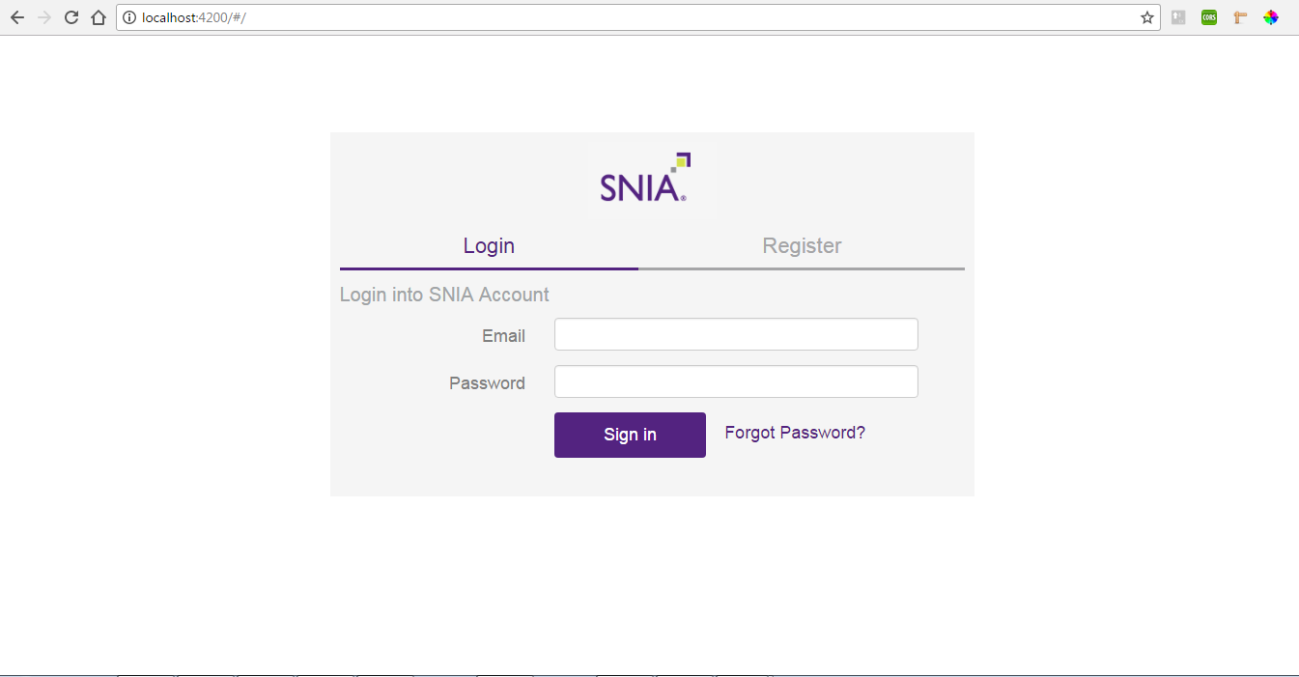

## Add a Swordfish Service

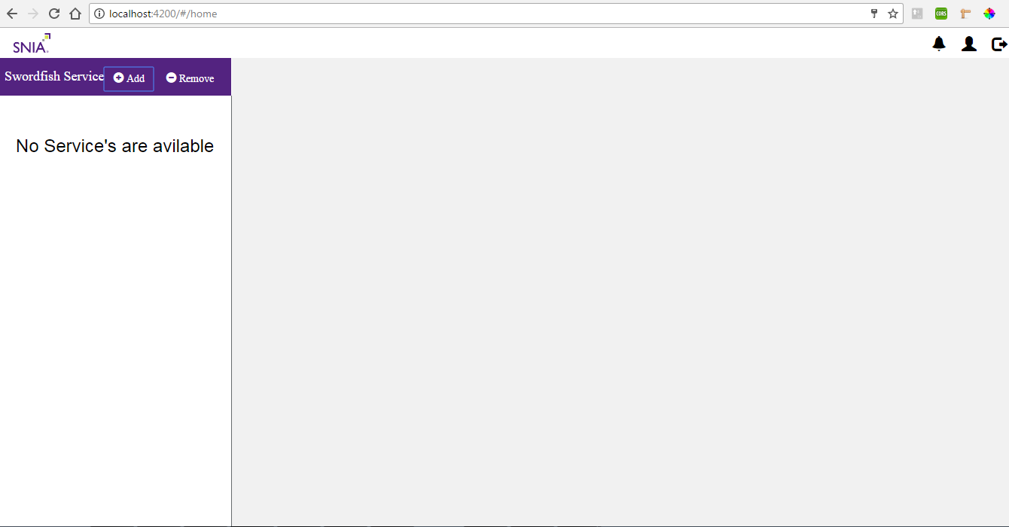

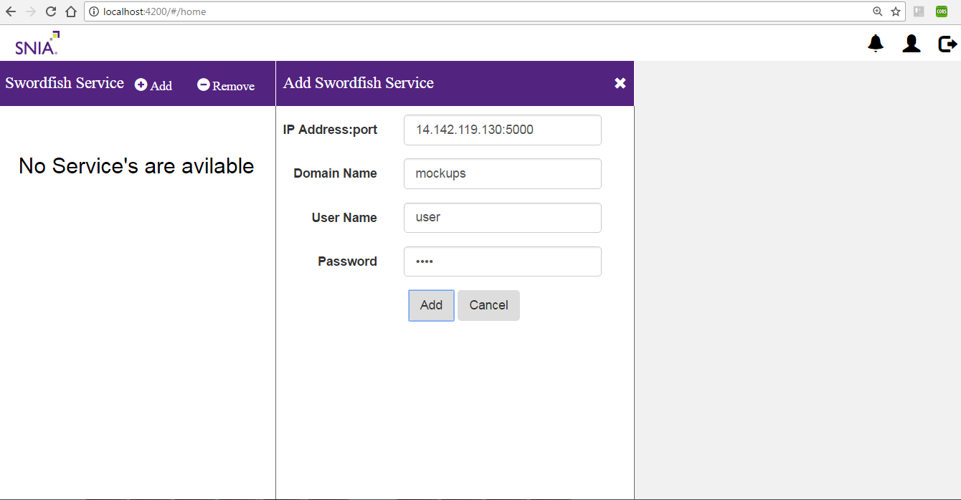

## Delete a Swordfish Service

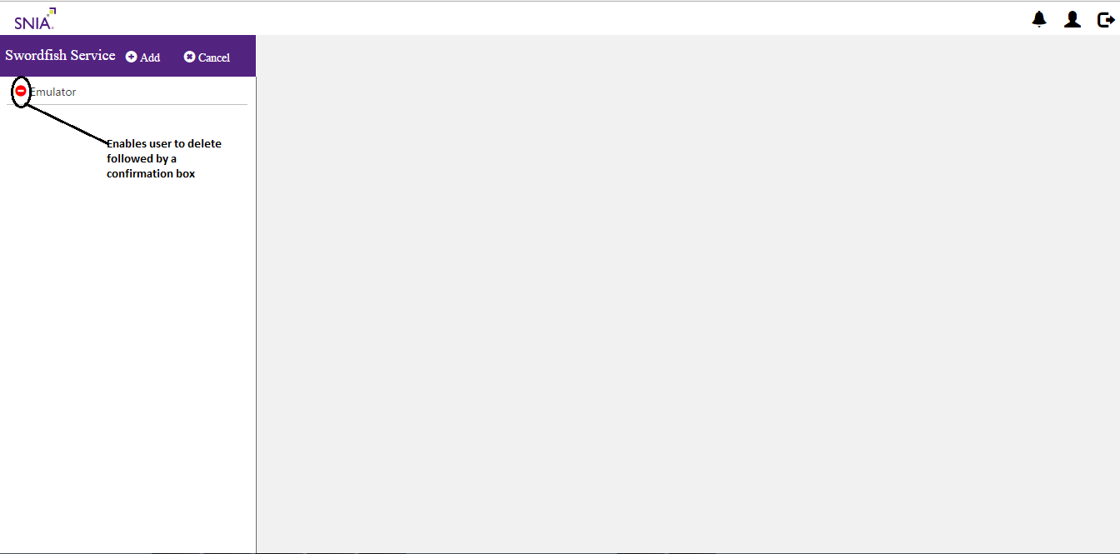

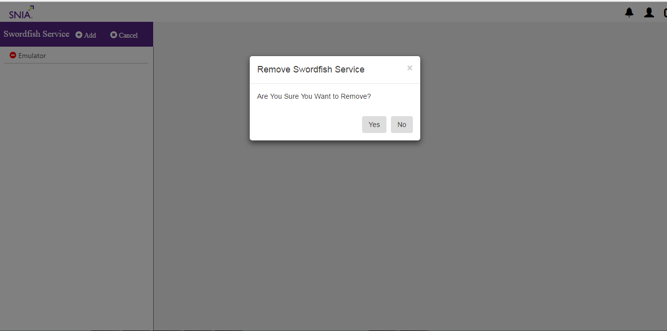

## Collections Page

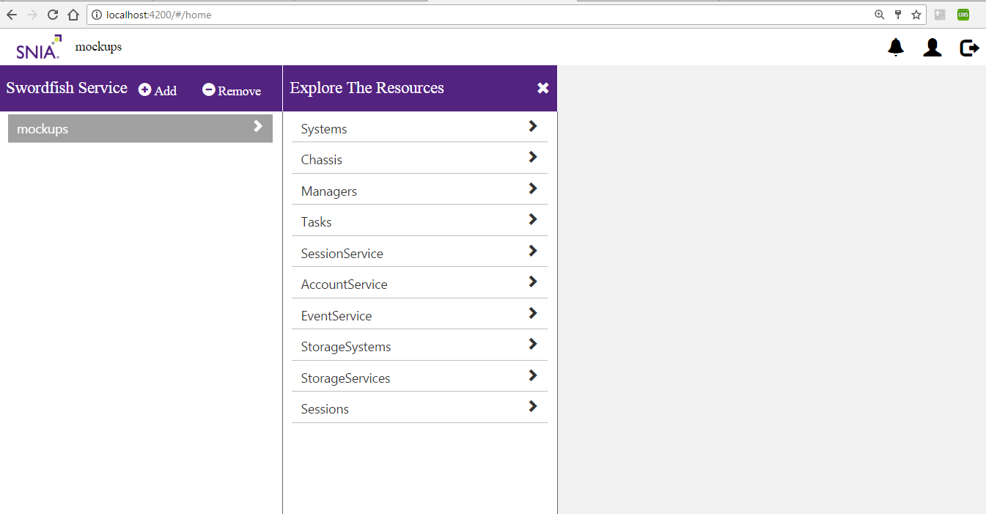

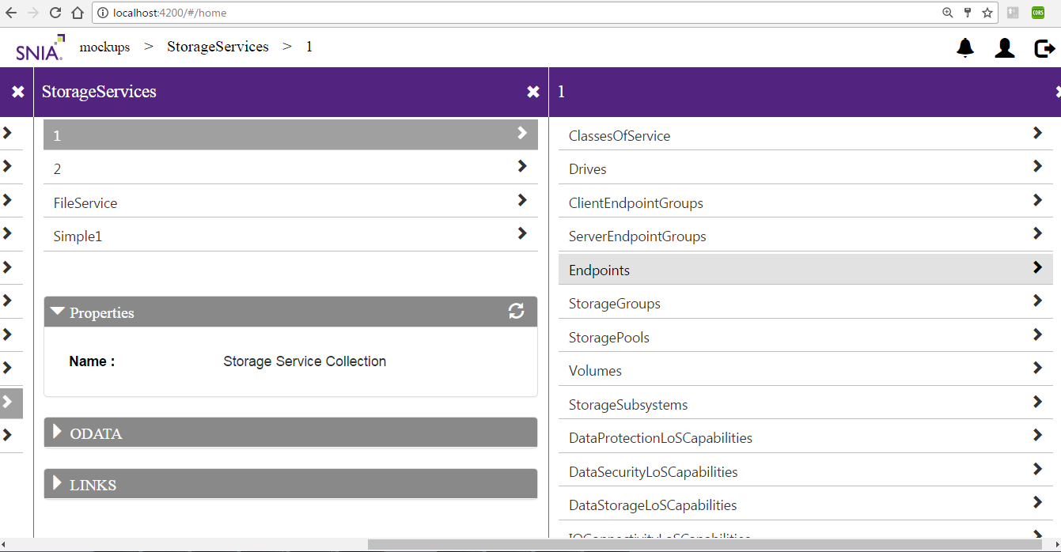

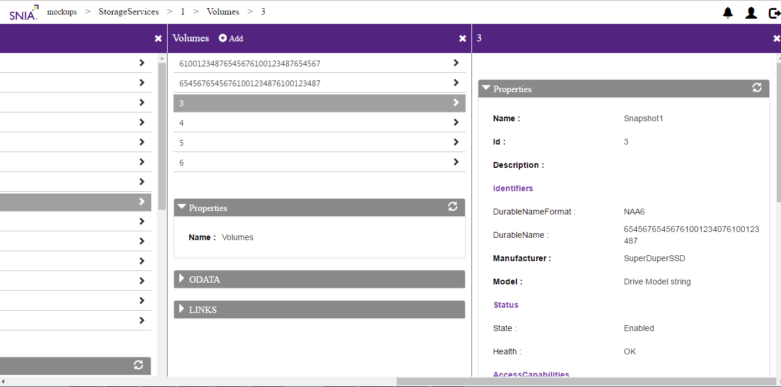

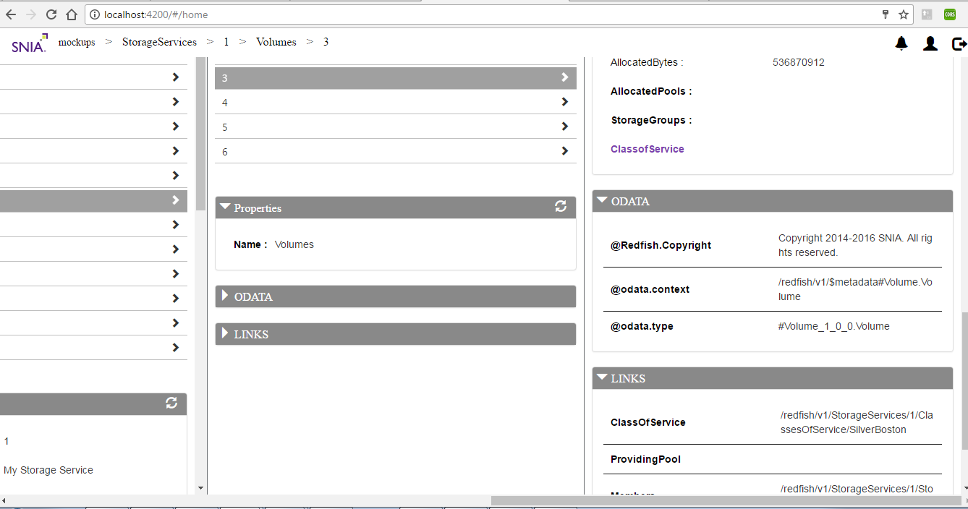

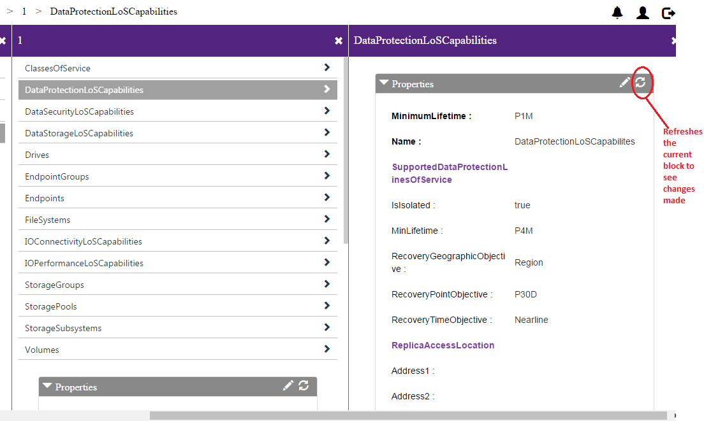

## Edit Properties

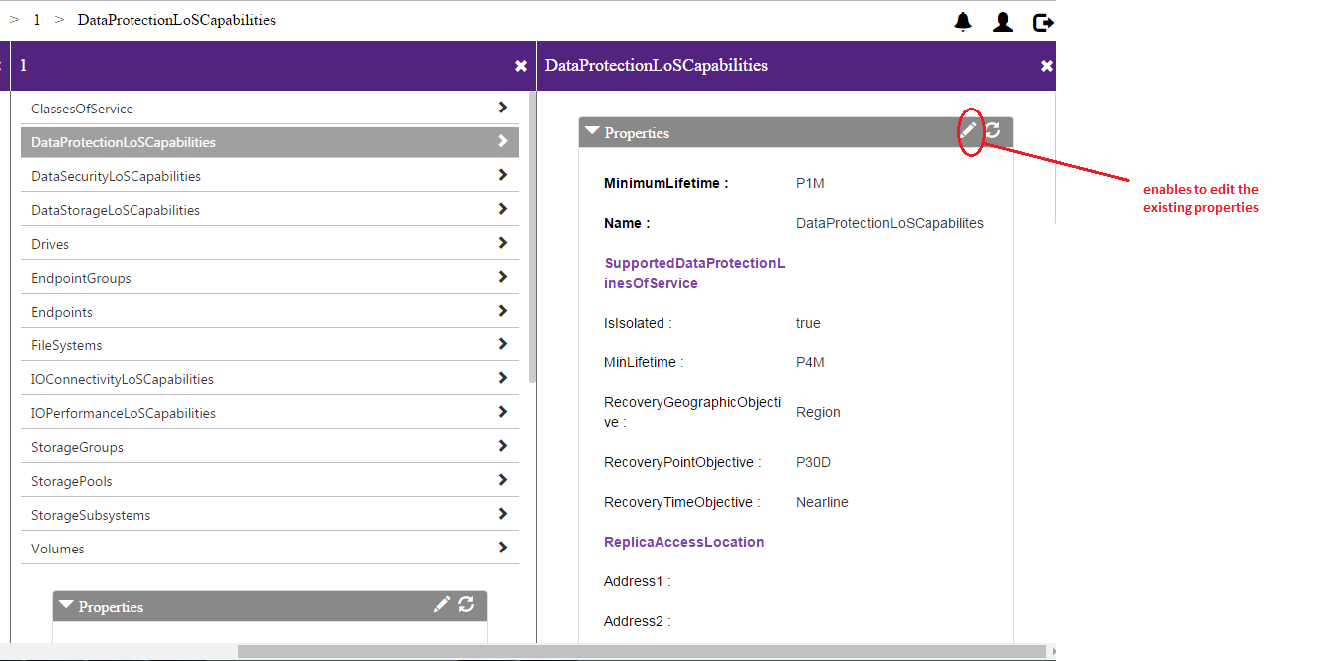

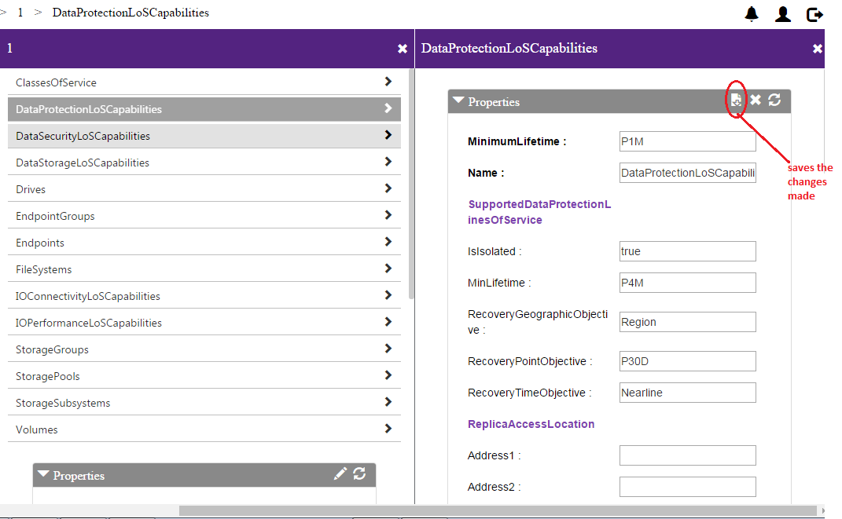

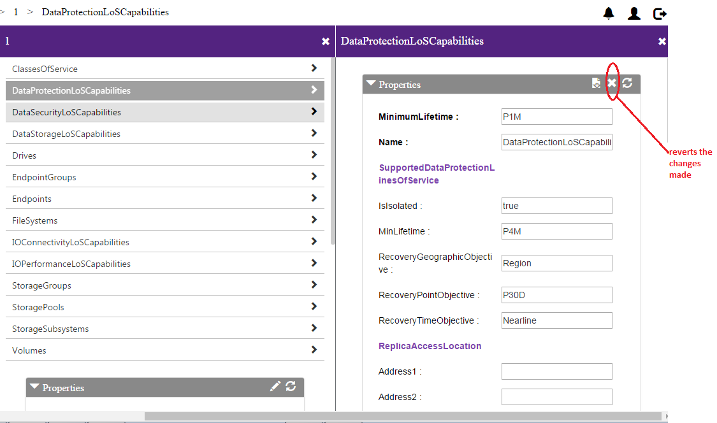

## Add a service to collection

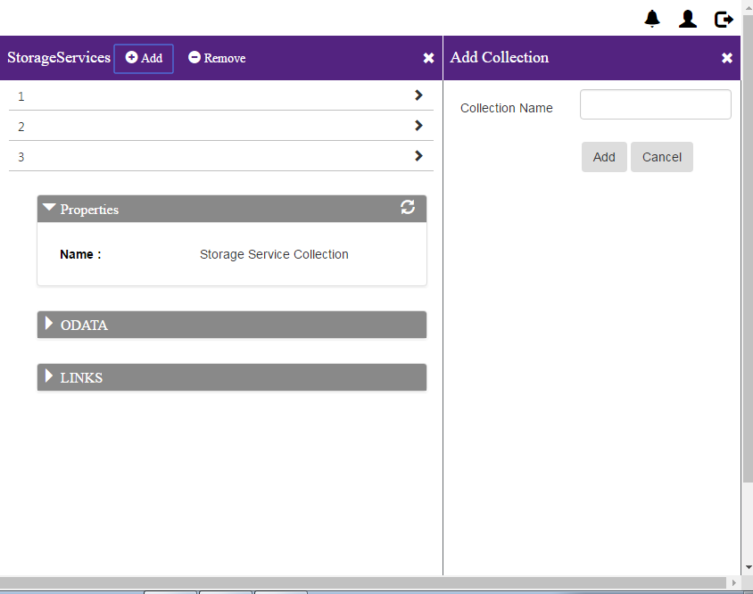

## Remove a service form collection

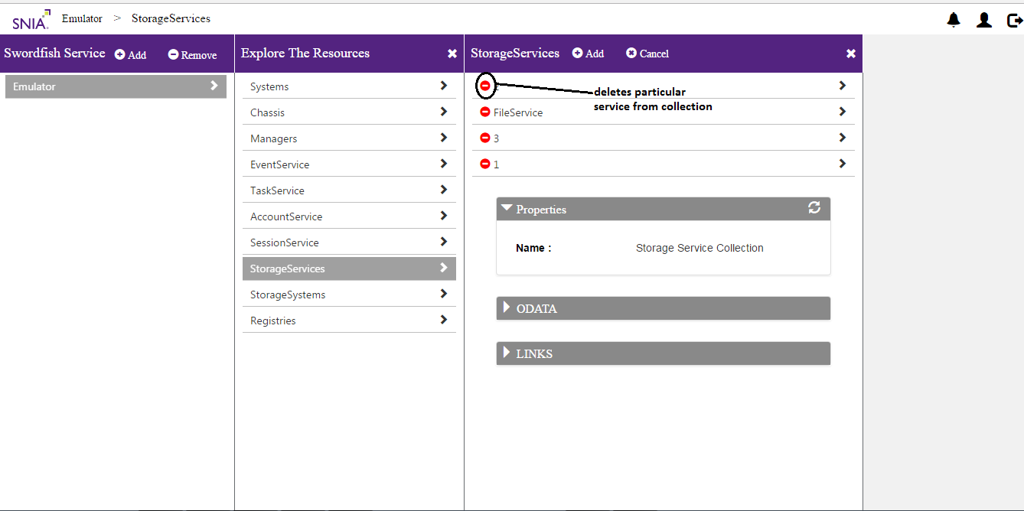

## Logout

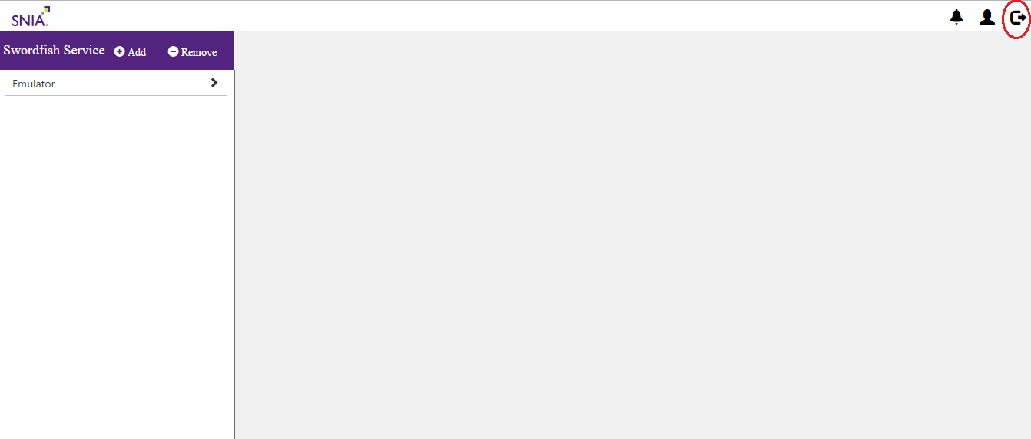

## batch commads

